*Ulises Almaguer Guzmán -* A01209070

*Topiltzin Hernández Mares* - A01703266

*Luis Jesús Morales Juárez* - A01703455

*Carlos Alfonso Sánchez Rosales* - A01703280

***First Advance Final Project: OverFlow***

***Proposal of the project: application area***

According to Manuel Bravo, a journalist form mexicanosprimero.org, have been the curious people the ones that have changed the world for ever, however, in Mexico there is a great problem, which is a widespread lack of curiosity in students in both private and public school at all levels of education (Bravo, 2013).

What has been mentioned above is closely or intimately related to the lack of a good educational structure, where in the schools tell us what to do and where to do it, replacing, in this way, various skills and knowledge that are inherent in human beings; Carlos Coello mentions that all people born with these characteristics, but the traditional Mexican school oppresses them. In fact Carlos Coello once said that “*although science has allow him to know many place in the world....after all, he is a little boy product of the educational system”* (Bravo, 2013).

On the other hand, from different sources, but specially from the news el Financiero, it is said that in the absence of professionals in the requested careers, companies prefer to hire graduates from other areas that do have the required skills; and it is not surprise that the skills that companies are searching for, are the ones related with curiosity, such as self studying, problem solving, leadership, critical thinking or decision making, just to mention some of them (Herrera, 2017).

In the same way, link with the problems mentioned above, the students that may have some kind of curiosity stored in themselves, and that actually search for the topics that they do not understand or that are difficult for them, they wait for the answer to appear immediately and without carrying out a deep search; so it is to be expected that once the answer is found, they do not continue with the search for that topic, and all of this largely due to lack of curiosity (Flores, 2010).

On the other hand, one of the most requested areas for learning is programming, which makes a lot of sense, since students are in a situation in which they lack a critical and logical thinking, as well as the curiosity of searching and the ability to solve problems, so students look for some tool that allows them to develop these skills (Universia, 2017).

In fact, programming allows the people who study it, to increase the productivity, efficiency and effectiveness of a person in their work, regardless of the profession they develop; on the other hand, programming helps to achieve more effective communication, helps to solve problems and, most importantly, develops learning skills (Universia, 2017).

In the same way, one of the problems of learning a programming language on the internet is the fact that there is so many information spread all over the internet, that surfing it in the search of what you are looking for, is really complicated and tedious; and this is going to generate that the user will learn bad programming habits (Universia, 2017).

As programming, being one of the most demanded areas, it is very obvious that the programming language that wants to be learned is one of the most worldwide wants to be learned; in fact, according to a study of Campus MVP, the most requested languages are those related with portability and the web, which has great coherence, since the internet is increasingly universalized.

Once said all those problems related to Mexican students, clearly all this is reflected in the various tests that are applied worldwide to measure the educational level, so it is not surprising that Mexico is the worst country in education within the OECD (Organization for Economic Co-operation and Development) ranking (Montalvo, 2013).

In fact, 55% of Mexican students do not reach the level of basic competence in mathematics, the same happens with 47% of students in science (Montalvo, 2013).

So once said all the problems that want to be tackled, such as lack of curiosity, the lack of skills related to this area, such as critical thinking, logical thinking, problem solving, leadership and decision making; the lack of a deep self-study that encourages curiosity and learning; which is clearly reflected in the low educative indexes of the country on a global scale; as well as the great demand of the students for learning an efficient and useful programming language;

We believe that the development of an educational platform will undoubtedly help to increase curiosity and self-study levels among students interested in programming areas, in the same way, due to the fact that such platform will contain truthful and functional information, will allow to reduce misinformation in the field of programming (of course, only on the programming languages that are taught). Closely related to what has been mentioned, and being clearly optimistic, it may have an impact at the national level, by raising educational levels by developing skills such as curiosity for self-study, critical and logical thinking, leadership and decision-making, which may have a clear impact in the science and mathematical areas of international exams such as PISA.

***Researching the "State-of-the-art"***

Today there are a variety of online study platforms, such as DevCode, Udemy, Skillshare, Khan Academy, Microsoft Virtual Academy, Coursera, to name a few, and if that were not enough or for some reason or other, we are not familiar with the platforms, we do not have to go far to find knowledge online, an example of it, are the various tutorials that the various content generators of YouTube offer to their subscribers (Universia, 2017).

These platforms consist on programs (software) oriented to the Internet, they are used for the design and development of courses or didactic modules in the international network. They allow to “improve” the traditional old school structures and develop individual and collective learning (Borrero, 2015).

Although these platforms offer a great variety of advantages such as:

* Learning customized, the student can have different ways to learn. You will choose the best platform, or the platform that you think, will be complete (Anonym, 2016).
* Receive feedback, when you end a course, some courses make quizzes, so this is a way that you receive it, or you have to deliver homework (Anonym, 2016).
* You are free to choose what you want, your necessities that fit into your own specific needs (Anonym, 2016).
* It allows you to contact and do business with students and entrepreneurs from all over the world, which in addition to enriching your education can be important connections for the professional field (Anonym, 2016).
* Online courses allow you to study at your own pace, without pressure, with calm to understand all the concepts at your own pace; coupled with the fact that they allow you to study at your hours so as not to leave aside your occupations or other educational plans (Anonym, 2016).

There are also a lot of disadvantages, such as:

* The students don’t have a human interaction (Armstrong, 2013).
* Online learning can be difficult, if it is meant for disciplines that involve practice (Armstrong, 2013).
* Cannot cope with thousands of students that try to join discussions (Armstrong, 2013).
* As there are many course available, the user may not know which is the best that fits is needs (Armstrong, 2013).
* Due to the fact of the great variety, there may be a lot of misinformation among all those platforms (Armstrong, 2013).
* The course by itself may not have good quality content, and therefore that helps increasing misinformation (Armstrong, 2013).
* As the user decides which course to take, there may not be any formal sequence in his or her education (Armstrong, 2013).
* The courses may be based in old school structures, so the online course may be insufficient and inefficient (Armstrong, 2013).
* Online methodology requires a high level of discipline, responsibility and organization, qualities that many people don’t have (Armstrong, 2013).
* There is a great irregularity in the formation of the students, so the courses are not suitable for the public (Armstrong, 2013).

In the same way, this type of platforms are lucrative, so a large amount of courses available on these platforms does not contain reliable information, since it is the goal of these platforms to do business and not educate people; so platforms like Udemy have discovered that their customers buy more when the courses are cheaper; so it is regularly, that these platforms make courses “crappy/cheap” instead of courses rich in knowledge (Wenstberg, 2016).

In fact, some studies show that educators and potential employers frequently emphasize the importance collaboration in classrooms and workplaces. Consequently, online courses, flipped classrooms and other personalized online learning experiences have faced criticism for neglecting the social aspects of learning. Example of it is what Halpin and Bergner point out, saying that: “s*uch software does not accommodate structured learning activities for small groups*” (Cordiner, 2016).

On the other hand, due to the fact that these platforms require a high level of discipline, responsibility and organization, which are characteristics that many Mexican students don’t really have, these kinds of platforms don’t really accommodate the needs and areas of opportunity that Mexican students show day by day. In fact according to the news El Financiero, only among 540 thousand people (including all ages) are studying in an online platform called Coursera in Mexico, now if we consider this a general statistic for other online platforms (that may have much less students), this represents a minimum percentage of the Mexican population, and in fact, a much less students in the Mexican territory (Anonym, 2016).

Finally, one great learning disability that has been documented in the area is the fact that online courses do not adequately include the different variables that influence the motivation to study (Bravo, 2013).

Example of it is the “perception of self-efficacy”, which is defined by Weiner as the judgments that each person makes about their capacity to carry out an activity, which greatly influences the effort dedicated to an activity or task (Bravo, 2013).

The "attributions", defined by Weiner as beliefs about the causes of successes and failures in an activity, which are associated with different feelings (Bravo, 2013).

And finally, the “motivation of achievement”, which is defined by a norm of excellence for performance in an activity; generally, in the school is established with the qualifications (Bravo, 2013).

***Opportunities for innovation***

Once the previous analysis is done, where it is possible to realize the strengths and weaknesses of online courses, it is time to propose a solution to this problem. The solution that our development team tries to give clearly is focused or achieving a clear reduction of the disadvantages of online courses, while keeping the positive aspects of them.

However, such work is not an easy task since in many cases the points to be countered contradict themselves, an example of this is the fact that the online courses are based on old school educational structures, however, the courses online they demand what the old school instilled in us, such as discipline, organization and responsibility; but at the same time the course must be flexible (Wenstberg, 2016).

So, the solution that our developer team will include the positive aspects of online courses while tackling the next problems:

* As there are many courses available, the user may not know which is the best that fits is needs.
* The courses may be based in old school structures, so the online course may be insufficient and inefficient.
* Due to the fact of the great variety, there may be a lot of misinformation among all those platforms.
* The course by itself may not have good quality content, and therefore that helps increasing misinformation.

On the other hand, one problem that will be partially tackled by our solution, but it could never be solved by online courses, is human interaction.

Once said which are the areas of opportunity our solution will try to approach, we consider that the innovation opportunities are given by:

* *Specific Needs*: if the course that a user is looking for is related or closely related to programming on the web, learning different web programming languages or having an introduction to the web programming, the course that our platform provides will be the best one.
* *New Learning Structure*: It is known that students (especially of the millennial generation) want answers to their questions in an immediate way and if possible instantaneously. Having said that, the development team, being a group of students, knows what the specific needs of the young people are, so this platform will provide a new learning system which knows and adapts to the needs of the target audience; including the skills that are intended to be developed (curiosity, self-study, determination, organization, etc.) adapted to the target audience. In short, it can be summarized as the knowledge of one student to another student.
* *True Information*: One of the pillars in which our proposal will innovate, is the fact that the information provided will be totally helpful and hundred percent true, the above will be achieved due to the fact that this platform is freely accessible, so it has no lucrative interests, making the various tutorials and aids provided, focus on providing quality content and not content to generate incomes.
* *Help Forums*: It refers to the fact that the platform itself will have a support forum, which will be controlled by the development team, which will allow greater involvement by the users. Due to the fact that it will be supervised by the development team, this allows having a greater control over the publications, in such a way that it can be a forum with constructive information and will not generate more misinformation.

As this forum has the Mexican population as the target audience, and knowing all the lacks that Mexican students show, this platform will try to introduce self-studying and curiosity in a very subtle way, where the users may need to search for what they need and must be in a certain way self-studying, but will provide answers to their specific questions, not without first having inquired slightly about the subject.

In a nutshell, a platform that is the introduction to the world of self-study and curiosity.

The clear evidence of differentiation of this platform with respect to existing ones is the fact that the information provided will be of quality since it will not be compromised for lucrative purposes. In the same way, this platform is directed exclusively to the Mexican market, so it differs from the others by providing the information that students need by promoting self-study and curiosity at a basic level, so that students begin to have that ability to solve problems by themselves. As it has been said before, this platform is the introduction to the world of self-study and curiosity.

***User's profile***



*Photo:* (image).

*Fictitious user name:* Juan Pérez Gómez.

*General characteristics:*

* 19 years old.
* Speaks English, Spanish and is learning French.
* Currently studying computer systems.
* Lover of mobile technology.
* Studying in “Tecnológico de Monterrey Campus Monterrey”.
* Working with a group of friends in a business of web pages.
* Attends various international events.
* Enters daily to different programming forums
* Generates articles and reports every day.
* Checks news about new technology and science advancements.
* Avoids handling printed information, he loves digital format.
* Invests many hours daily exploring online information, especially about programming.
* Has installed in his cell phone numerous applications and games that have to do with logic and math.
* Has won state and national mathematics Olympiads.
* Generally, uses the calendar to planify his week events.
* He is strict with the rules, thinks that things must be done in the correct way.
* Attends coding afternoons each Friday at 2:00 pm.
* Participate in the philanthropy student group.
* He likes sci-fi and futuristic technology movies very much.
* He loves coffee.

In general, it can be said that the general characteristics of the target audience are:

* Students of information technology careers, designers, young people interested in web design that want to learn new development skills to create better web sites.
* The profile of the target audience must be a combination of a creative mind for the realization of the design of a page, however, at the same time must have a certain level of logical and deductive capacity for understanding the functions and elements of the various programming languages.
* The user profile must be pragmatic and utilitarian.
* The user must have that little flame of curiosity and desire to learn (such flame may be almost off).
* The user must have a certain level of interest in science and technology topic, especially related to programming.

*Age group*:

The target audience of the application is between **15** and **25**, this is due to the fact that according to a study done by Psychological Science, during this age you are gaining knowledge to apply in your future life; and in fact, during this age the user has a greater ability to decode numbers and symbols; which is a really useful ability for learning programming languages.

*Skills that the user group of the interactive system must have:*

The user needs to think in a really logical and critical way, in the same way, he or she must be familiar with the different basic programming concepts such as variables, constants, functions, methods, control structures.

However, in addition to a rational mind, the user must have a creative mind, in order to create the different web designs.

It is completely necessary to know how to manage the computer and some stuff about Windows in order to run the application; the user must know how to run the browser of his or her preference.

Finally, the user must have really developed skills in analysis, in order to easily understand all the programming concepts.

*Activities that the user group usually would perform with the interactive system:*

Due to the fact that this is a platform design to teach, and the students to learn, the main activity that the user may get access to, is to different tutorials, explanations and examples of different programming languages for web design, some of them are HTML, CSS, EcmaScript 6, Vanilla Script.

On the other hand, the application is also intended to serve as a platform on which the user will have the ability to read articles and information about new technology that has to do with web design (encouraging curiosity and self-study).

On the other hand, it also provides the user with a discussion forum, where the user can present their concerns about the various web design topics.

Finally, the platform will allow the user to measure their progress in the learning process that has been done and will be achieved through different exams or tests that the platform contains.

***Concept design of the interactive system***

*Name and Logo:*

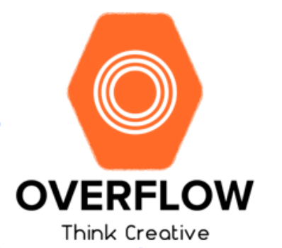

The name of our platform it’s going to be the same as our team’s name, Overflow. This way we can keep simplicity with our team name.

We can interpret the name "Overflow" as a metaphor of what we want to achieve in this project; so it can be said that it has two main definitions.

On the user's side, our goal is that the user can "overflow" with knowledge by using our learning platform; on the other side, from the developer perspective, we want to "overflow" with new knowledge that we will learn while performing this project.

*Color Palette:*

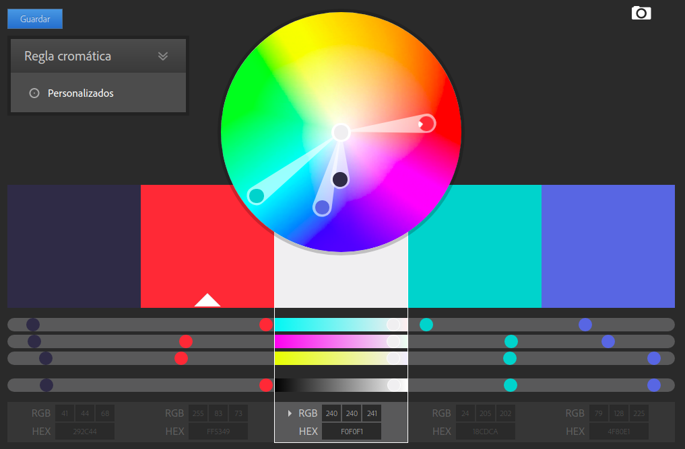The color palette that will be used in our project is the one that provide (shown) in the picture.

The reason why we chose those colors is because according to different studies that have been made in this sector, those colors are the ones that encourage and promote learning.

The blue color represents motivations, quality needed by the students in order to initialize their lives in the world of curiosity and self-study (Universa, 2017).

The yellow color is used to symbolize quality and interest (Universa, 2017).

On the other hand, orange and dark blue are used to symbolize productivity, positive attitude and creativity (Universa, 2017).

In fact it can be seen that all the skills and characteristics that represent the colors that are going to be used, are in fact the ones that the platform is trying to spread and inculcate in the students (Universa, 2017).

*Fonts:*

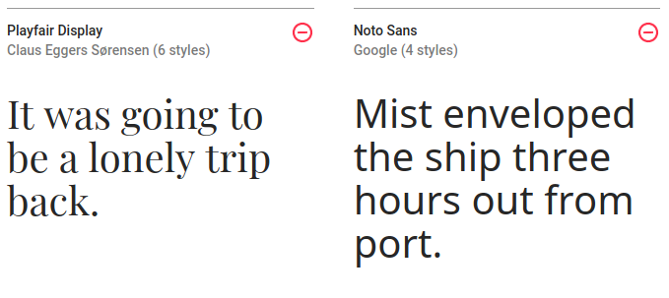

These kinds of fonts are, currently, very well accepted by the users, because help to keep clean the interface and are very light. Maybe in future, we’ll change these fonts for others with more quality.

The main reason why that type of font was chosen is because of its simplicity, it is necessary that the page is easy to read and understand. In other words, it is utilitarian and pragmatic, concepts that the Overflow project tries to transmit.

*Alignment type*:

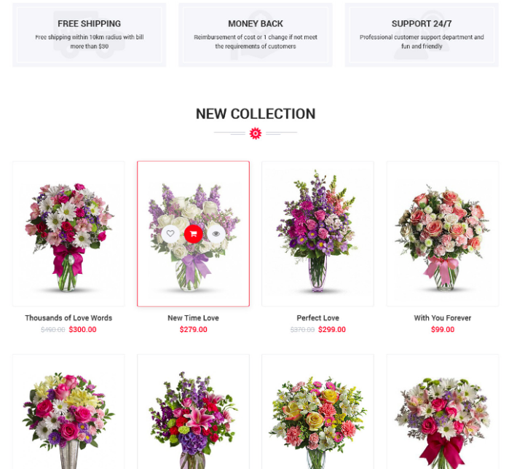

As you can see in the image, the platform will be gird based. This “new” display type is used by almost all the online platforms, like CódigoFacilito.com, PluralSight.com, Medium.com, etc.

We’ll try to keep this alignment type, but the design of the cards of our system is going to be very different from the ones in the picture, ours will be Material Design based; with more shadows, different z-indexes and flat images.

The main reason why this type of alignment was chosen is the same as mentioned in the font aspect, the main intention is to maintain a clean graphic interface that is pleasant to the taste, that is utilitarian and pragmatic, easy to understand and to see; in such a way that facilitates and optimizes the search for information (Borgen, 2017).

*Location / Geographic extension and Cultural differences:*

The main target audience of our project (geographic extension) is going to be the Mexican students, so to begin with, the language in which the program will be written will be in Spanish, in the same way, due to the fact that the target audience of the product are the Mexican students, it is necessary that the platform for quick and concrete responses to the doubts presented by the students, however, at the same time, should encourage self-study and curiosity.

In the same way, because this platform is entirely designed for the Mexican region, there will be no differences depending on the region, especially due to the fact that the Mexican nation shares the same culture, and in general the same principles.

*Technologies with which the components of the interactive system will be displayed:*

The technology that we are going to implement in the platform are going to be: HTML5, CSS3, ES2016, libraries like FlexboxGrid, Babel, maybe React and React Router and the Google’s real-time database: Firebase. As we will use ES2016, we need to transform the new syntax to another more supported by the majority of the web browsers; this is why we’ll use Babel.

We’ll use firebase because, according to Pier Bover of FreeCodeCamp, Firebase is one of the best and most potent real time databases in the world. This is because is supported by Google’s servers. And this database linked with React is one of the best development stacks in the market (Bover, 2017). With React and Firebase, we’ll have real-time data, static hosting on “steroids” and many, many super powers, like:

* OAuth authentication
* File Storage
* Database Backups
* Automatic Scaling
* CLI for deploying and other duties
* Free tier
* And the craziest: Firebase Functions

With the last one, Firebase Functions, we can use the whole potential of Google Cloud Platform, programming specific responses of URL, like payments, API’s and even emulated relationships.

In the other hand, using Firebase for a medium project like this one, maybe, will be a pain in the neck. As this database is relatively new, there is a lack of several functions:

* Real querying capabilities. Search, joins, the whole enchilada.
* Some sort of references likes MongoDB or RethinkDB.
* Real offline persistence with Javascript.
* Give me more analytics.

But, with the proper good practices, we think we will be able to get this project to the actual web, with the minimal bugs and issues.

***Interaction Design***

*Interaction Style*

With respect to our website is going to be simple, there will be no necessity for any instructions, the interaction of the user with the platform will be direct manipulation. So, by making this platform by direct manipulation, we can achieve several things, first, it will help to the development of curiosity and abilities such as self-study, decision making, among other; on the other hand, it will help to keep the platform clean and minimalistic, in a way that you can find what you need.

*Type of Interface*

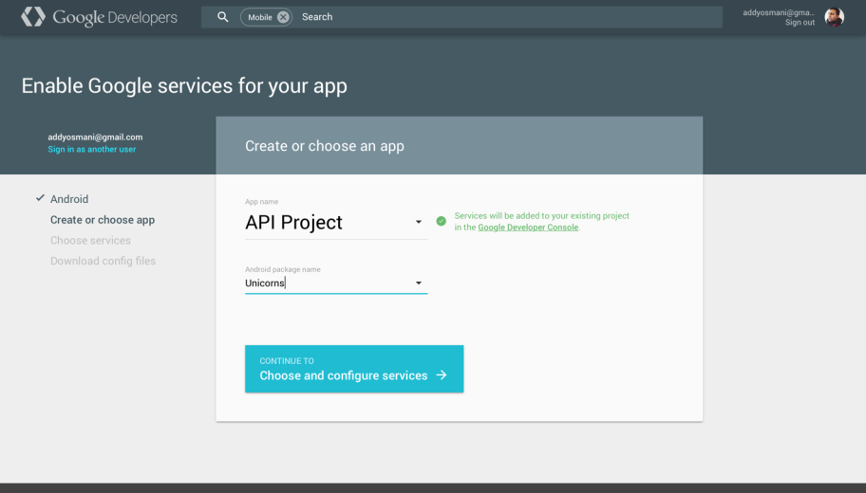The interface of the platform will be clean, according to the latest trends of web design. The design philosophy we will use is going to be **Google’s Material Design**. This way, we can save time in the design in order to make a better functionality of out project. As has been mentioned several times above, the interface that is going to be presented tends to be minimalist, so that the information is easy to search and find.

*Material Design ‘Lite’ Interface example*

*Generated User Experience and General interact:*

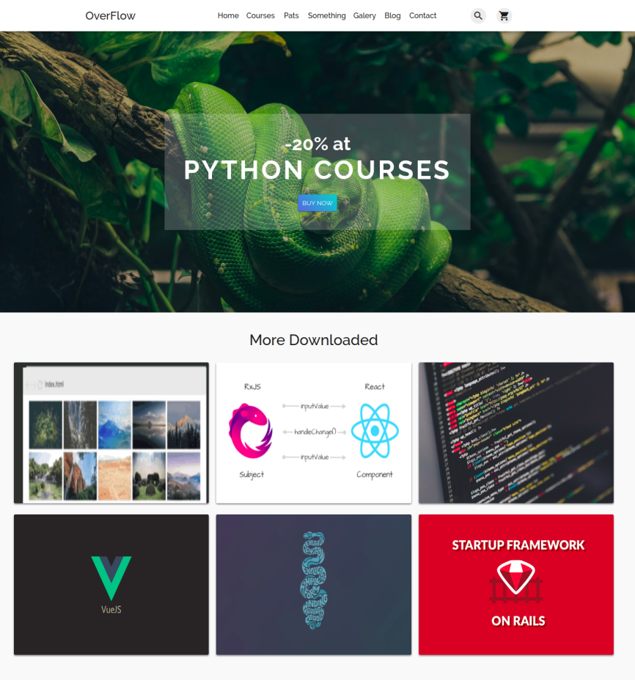With Material Design the UX will be more comfortable because almost all the regular users we expect to use our platform are familiarized with this kind of designs.

The students are going to interact with our system in many forms. There will be a global Navigation bar, with links to all the important parts of the platform. Images, buttons and links will be available too.

*OverFlow main page example.*

*Interface Diagrams:*

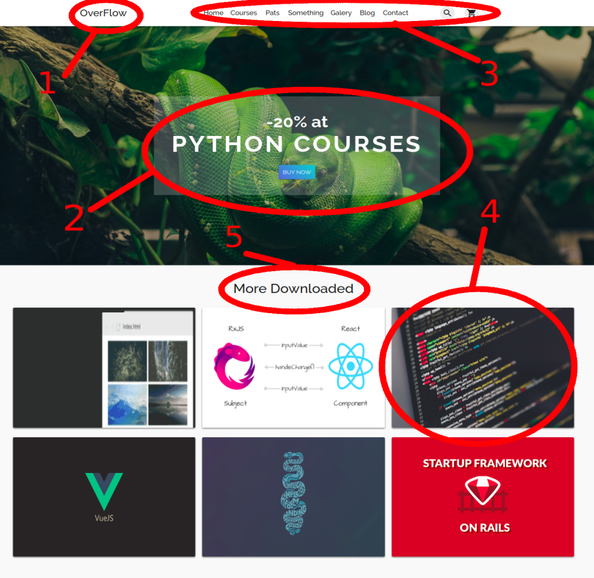

1. - Logo: According to Ángel Gonzalez in his article about web design (Gonzalez, 2012), what people sees first, is the upper left corner of the sites, so we want people to see first our name.

2. - The offers and promos: To keep the interest of the users, we’ll use a carousel banner as a header of the site. This way we can keep the attention of the visitors in what is important.

3. - The menu: As Ángel Gonzales mentioned in his article, people scans the sites like an “F”, so it’s important that people don’t lose the attention of the content of the site.

4. - The Courses: According with what we were saying above, the alignment type of the site will be a Grid System. We’ll use the image grid system to keep a clean looking interface.

5. - Titles: This will help the users to don’t lose any information of the site.

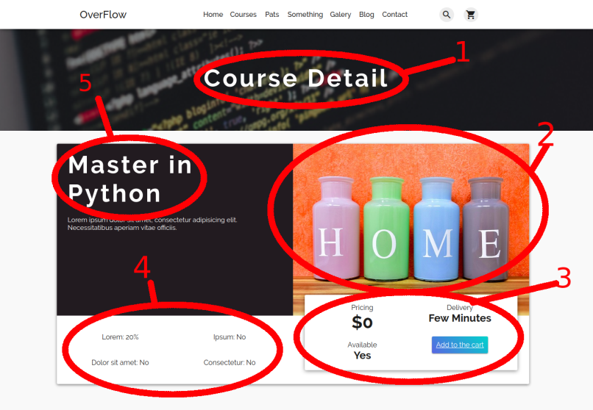

1. - Title of the section: To help the visitors and students aware of where they are in the site.

2. - Image: Related to the course they will acquire.

3. - Download Details: Here will be specified if the course has any charge and the time will be available for download.

4. - Details: About the course, like discounts, certifications and others.

5. - Title of the Course: This way, the users will know what course they are looking to.

*Functional diagram:*

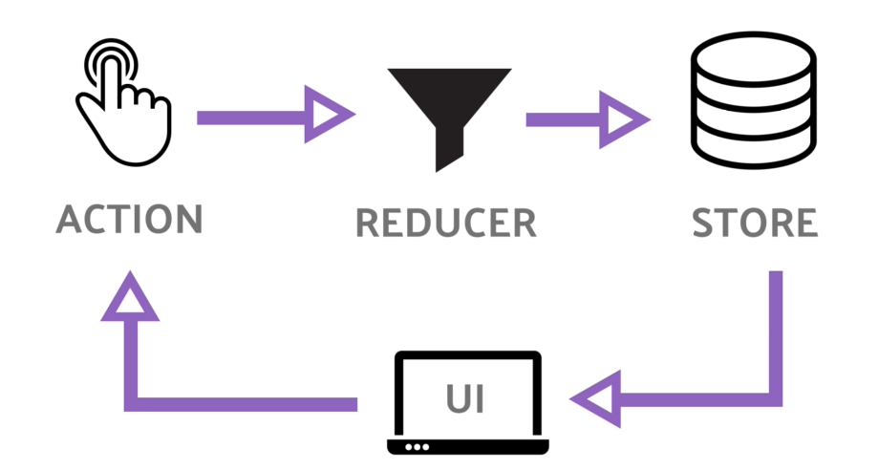

***References***

Armstrong, S. (2013). What Are The Advantages And Disadvantages Of Online Learning? 02/07/2018, de eLearning Industry Sitio web:<https://elearningindustry.com/advantages-and-disadvantages-of-online-learning>

Borrero, J. (2015). ¿Es la educación virtual buena o mala? 02/10/2018, de Educacion Virtual Sitio web: https://revistaeducacionvirtual.com/archives/1497

Bravo, M. (2013). ¿DESPRECIAMOS LA CURIOSIDAD? (I). 02/10/2018, de Mexicanos Primero Sitio web: http://mexicanosprimero.org/index.php/educacion-en-mexico/nuestra-opinion/item/despreciamos-la-curiosidad-i

Cicero, S. (2016). Why Platforms need to be Engines of Learning. 02/07/2018, de Stories of Platform Design Sitio web:<https://stories.platformdesigntoolkit.com/platforms-are-engines-of-learning-4f7b70249177>

Cordiner, S. (2016). ‘Cheap’ Online Courses: Are they ‘bad quality’ and should you bother selling your online courses when they go so cheap? 02/07/2018, de Medium Sitio web:<https://medium.com/@sarahcordiner/cheap-online-courses-are-they-bad-quality-and-should-you-bother-selling-your-online-courses-eab5bfcb66c4>

Dans, E. (2017). Machine learning: platforms and developers will set the pace. 02/07/2018, de Medium Sitio web:<https://medium.com/enrique-dans/machine-learning-platforms-and-developers-will-set-the-pace-c6f1163def4>

Anónimo. (2016). ¿Qué estudian los mexicanos en línea?. 02/10/2018, de El Financiero Sitio web: http://www.elfinanciero.com.mx/universidades/a-los-mexicanos-les-gusta-estudiar-en-linea.html

Anónimo. (2016). Las 10 ventajas de elegir un Curso Online. 02/10/2018, de Cemaer Sitio web: http://www.cemaer.org/las-10-ventajas-de-elegir-un-curso-online/

Flores, R. (2010). Un estudio sobre la motivación hacia la escuela secundaria en estudiantes mexicanos. 02/10/2018, de Scielo Sitio web: http://www.scielo.org.mx/scielo.php?script=sci_arttext&pid=S1607-40412010000100005

González, A. (2012). El ojo sobre tu web. ¿Lo sabías?, pues así la ven. feb., 11, 2018, de El Economista Sitio web: https://infoautonomos.eleconomista.es/blog/el-ojo-sobre-tu-web-lo-sabias-pues-asi-la-ven/

Herrera, M. (2017). Las empresas prefieren habilidades que conocimiento. 02/10/2018, de El Financiero Sitio web: http://www.elfinanciero.com.mx/bajio/las-empresas-prefieren-habilidades-que-conocimiento.html

Irwin, L. (2016). Las 10 habilidades que necesitarás en tu trabajo en el 2020. 02/10/2018, de El economista Sitio web: https://www.eleconomista.com.mx/finanzaspersonales/Las-10-habilidades-que-necesitaras-en-tu-trabajo-en-el-2020-20160719-0120.html

Material Design. (2018). Introduction - Material Design. [Online] Available at: https://material.io/guidelines/#introduction-principles [Accessed 11 Feb. 2018].

Montalvo, T. (2013). México, el peor de la OCDE en educación. 02/10/2018, de Animal Político Sitio web:<http://www.animalpolitico.com/2013/12/mexico-el-peor-de-la-ocde-en-matematicas-lectura-y-ciencias/>

Oliver, P. (2017). Medium. 02/07/2018, de Medium Sitio web: Enabling & Evaluating Real-Time Collaboration in Online Learning Platforms

Borgen. (2017). How to make your HTML responsive by adding a single line of CSS. Dom, 11 de Feb, 2018, de FreeCodeCamp Sitio web: https://medium.freecodecamp.org/how-to-make-your-html-responsive-by-adding-a-single-line-of-css-2a62de81e431

Pier Bover. (2017). Firebase: the great, the meh, and the ugly. Feb 11, 2017, de FreeCodeCamp Sitio web: https://medium.freecodecamp.org/firebase-the-great-the-meh-and-the-ugly-a07252fbcf15

Universia A. (2017). 34 plataformas gratuitas para aprender online. 02/10/2018, de Uni>ersia Sitio web: http://noticias.universia.com.ar/educacion/noticia/2017/01/02/1148009/34-plataformas-gratuitas-aprender-online.html

Universia. (2017). Por qué aprender a programar puede ser útil para la vida de cualquiera. 02/10/2018, de Uni>ersia Sitio web: http://noticias.universia.com.ar/educacion/noticia/2017/01/10/1148229/aprender-programar-puede-util-vida-cualquiera.html

Universia. (2017). Qué colores facilitan el estudio. Feb. 11, de Universia España Sitio web: http://noticias.universia.es/cultura/noticia/2017/04/17/1151485/colores-facilitan-estudio.html#

Wenstberg, J. (2016). The problem with everyone building platforms. 02/07/2018, de Medium Sitio web:<https://medium.com/the-mission/the-problem-with-everyone-building-platforms-78f8de32c908>